## PLOTS FOR VISUALISATION

1. Below plots shows incremental learning batchwise for bsize=50
2. Naïve Bayes

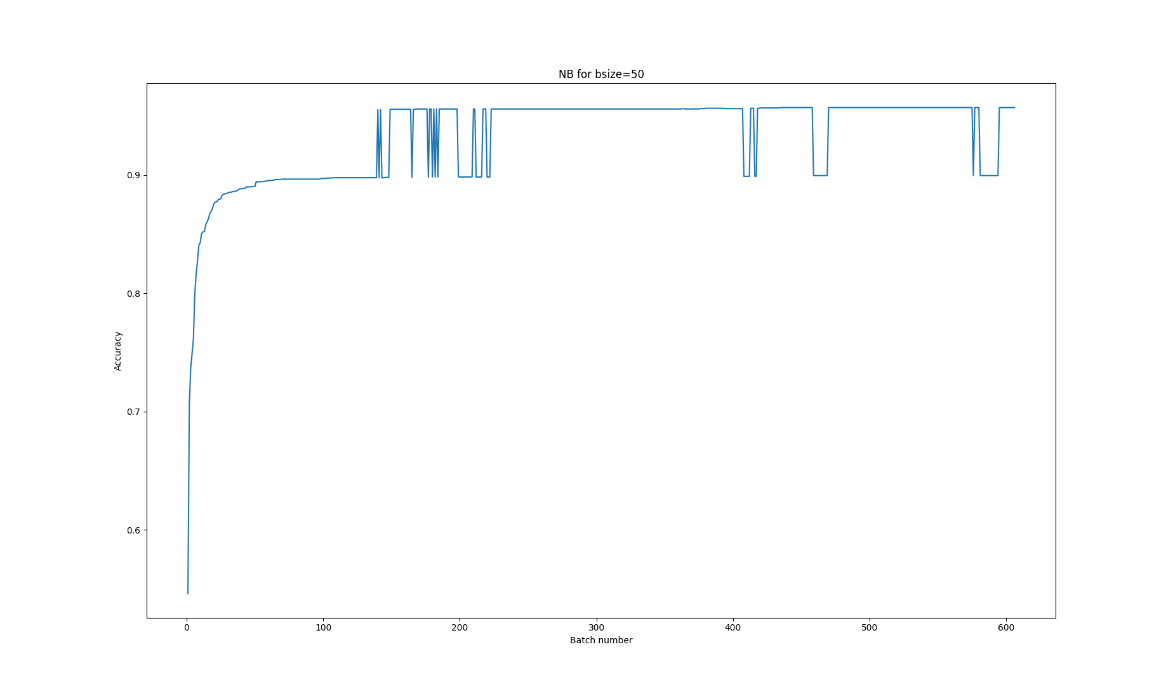

1. SGD

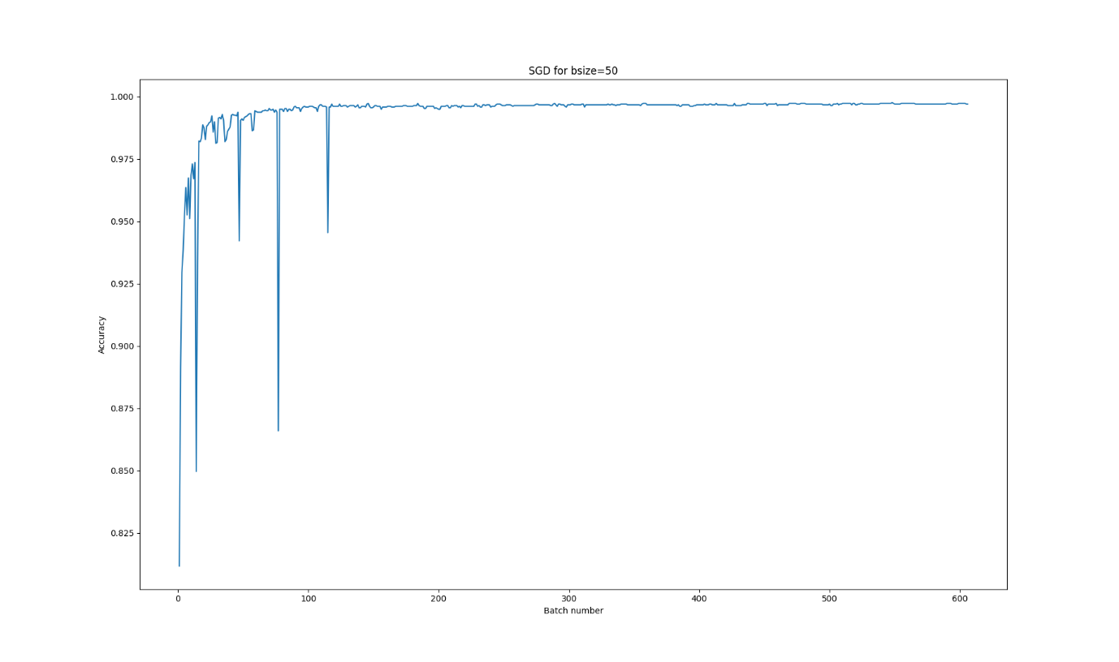

1. PAC

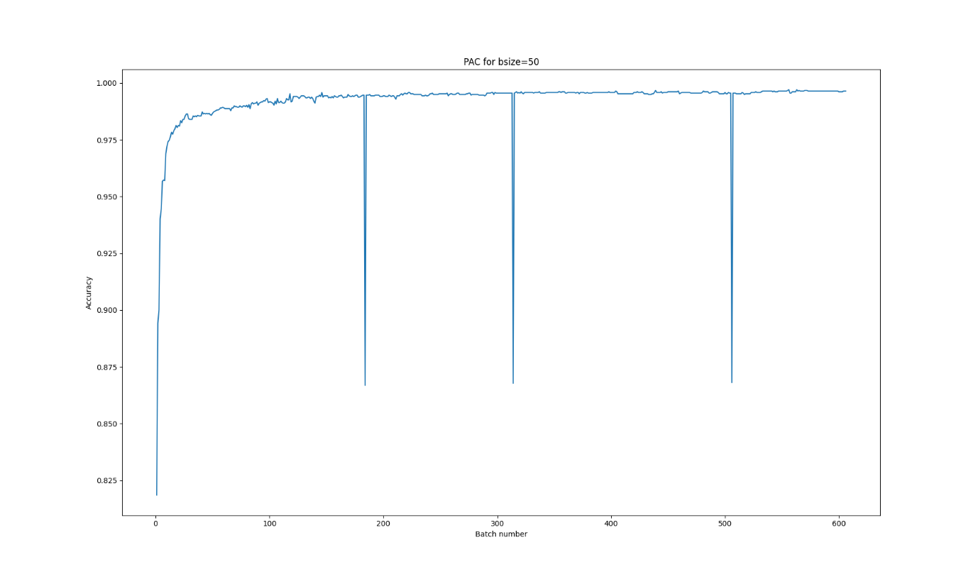

MULTIPLE LINE PLOTS FOR BETTER VIZUALISATION:

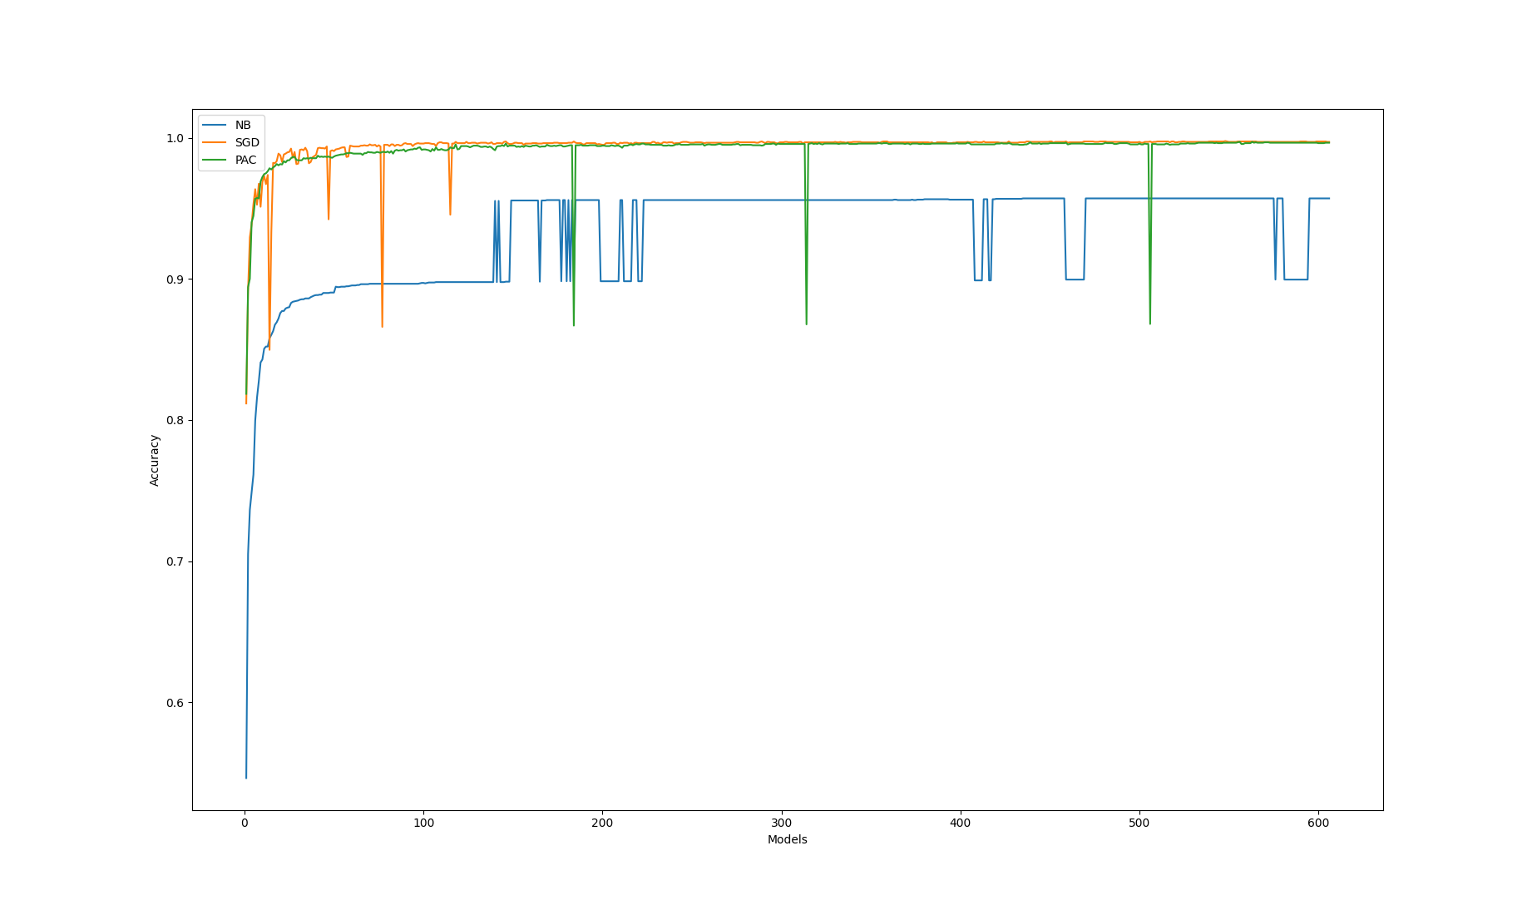

BAR PLOT FOR COMPARING ACCURACIES OF DIFFERENT MODELS:

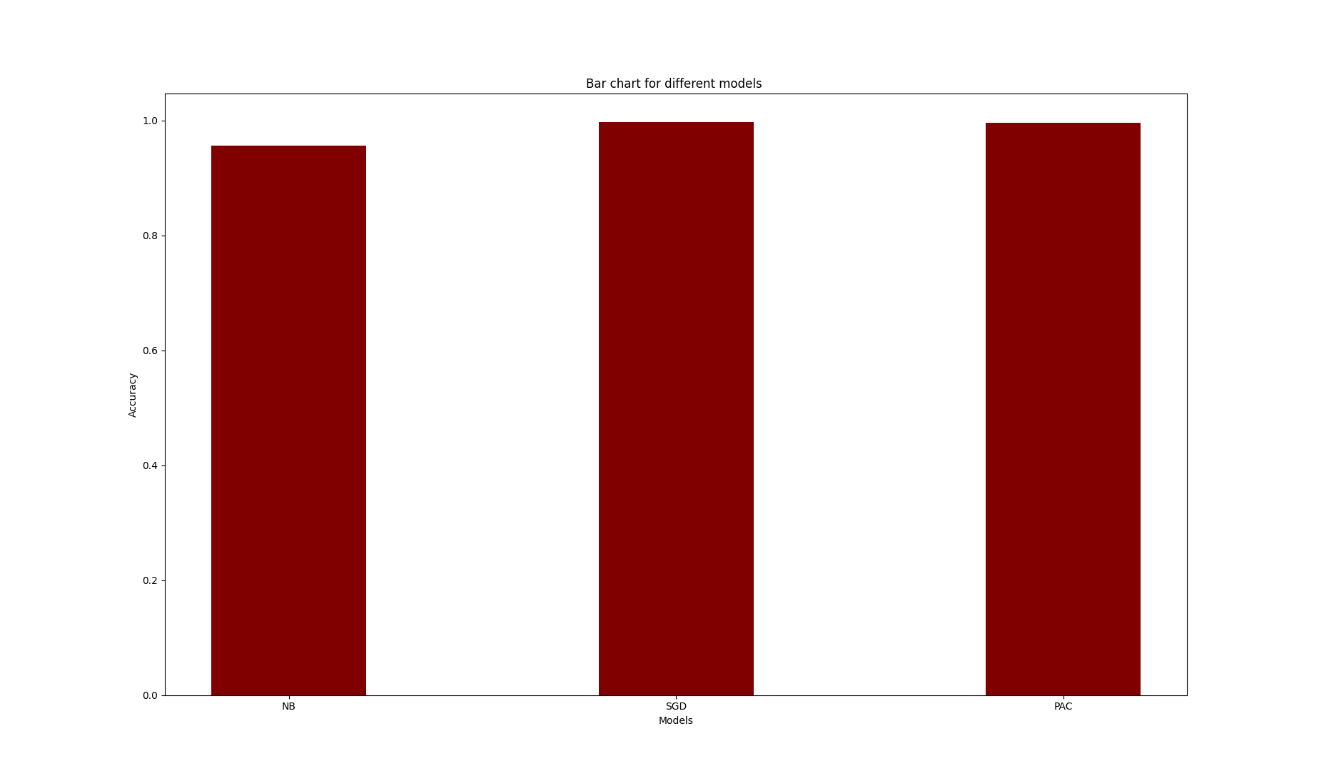

1. Below plots shows incremental learning batchwise for bsize=100
2. Naïve Bayes

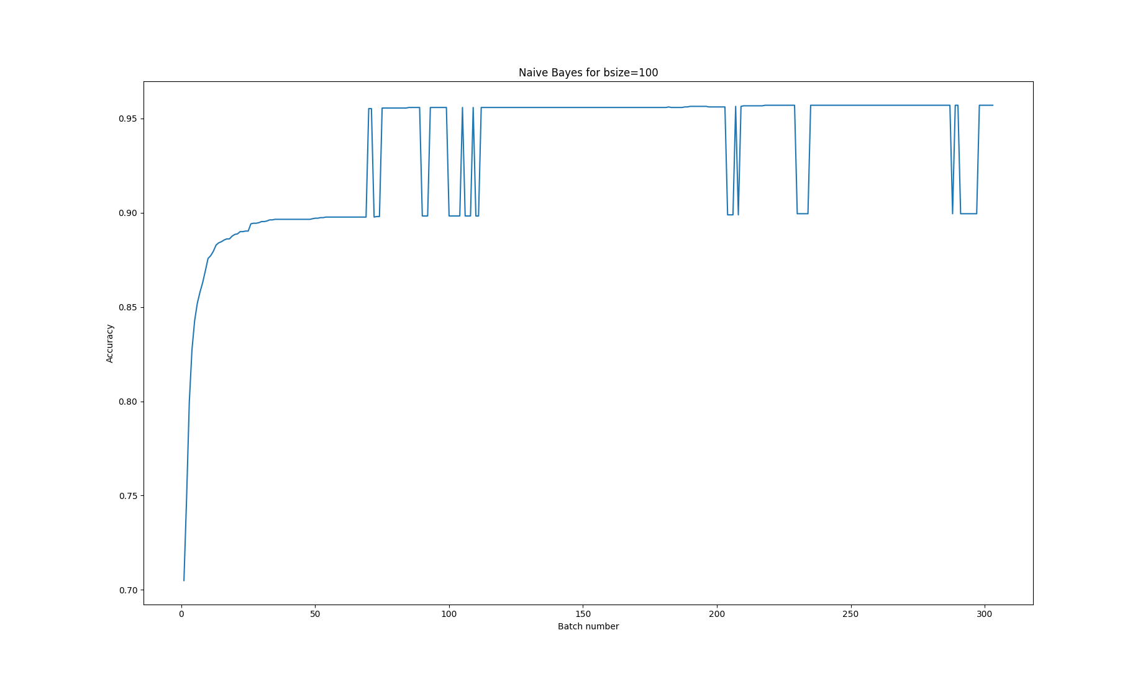

1. SGD

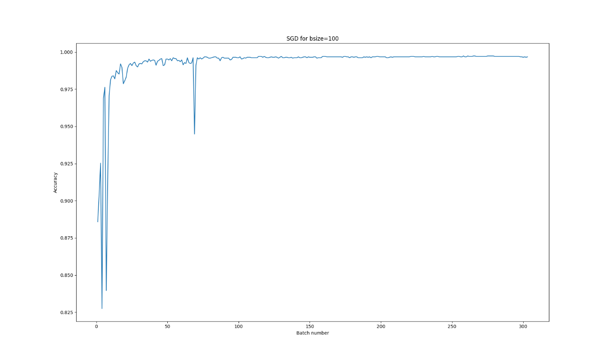

1. PAC

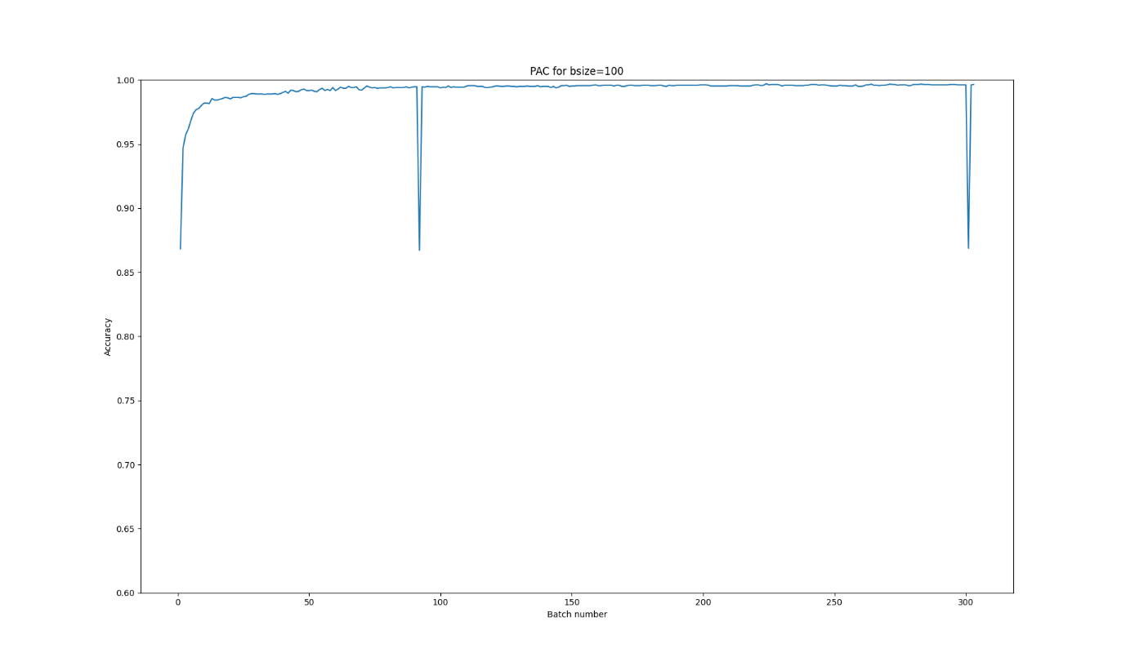

MULTIPLE LINE PLOTS OR BETTER VIZUALISATION :

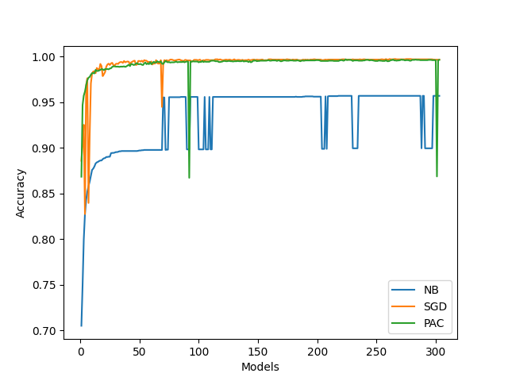

BAR PLOT FOR COMPARING ACCURACIES OF DIFFERENT MODELS:

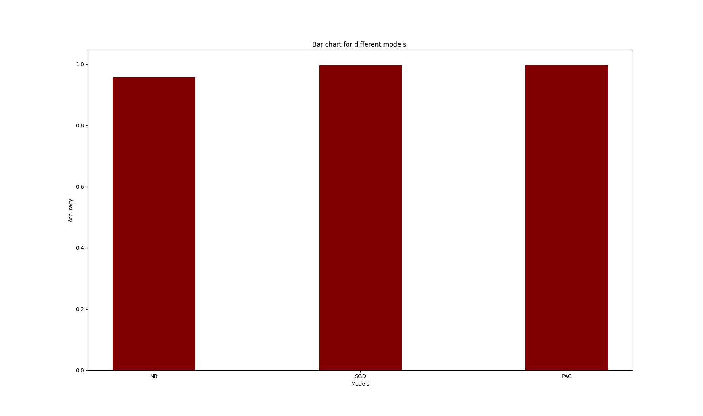

1. Below plots shows incremental learning batchwise for bsize=500
2. Naïve Bayes

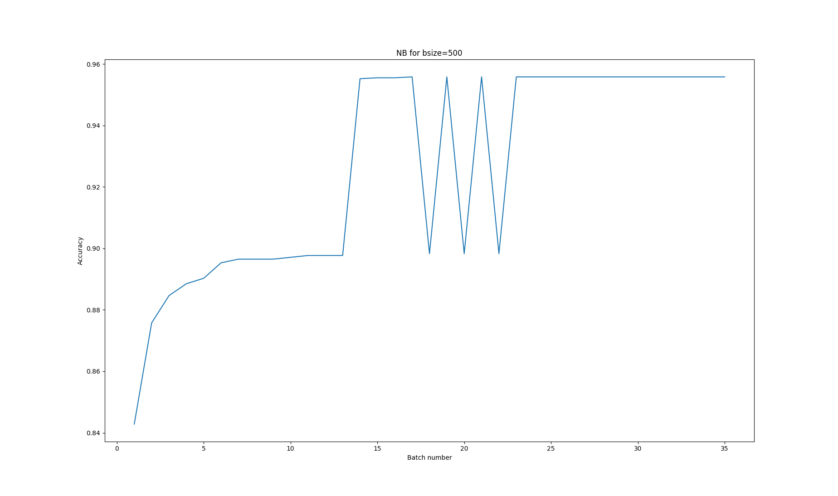

1. SGD

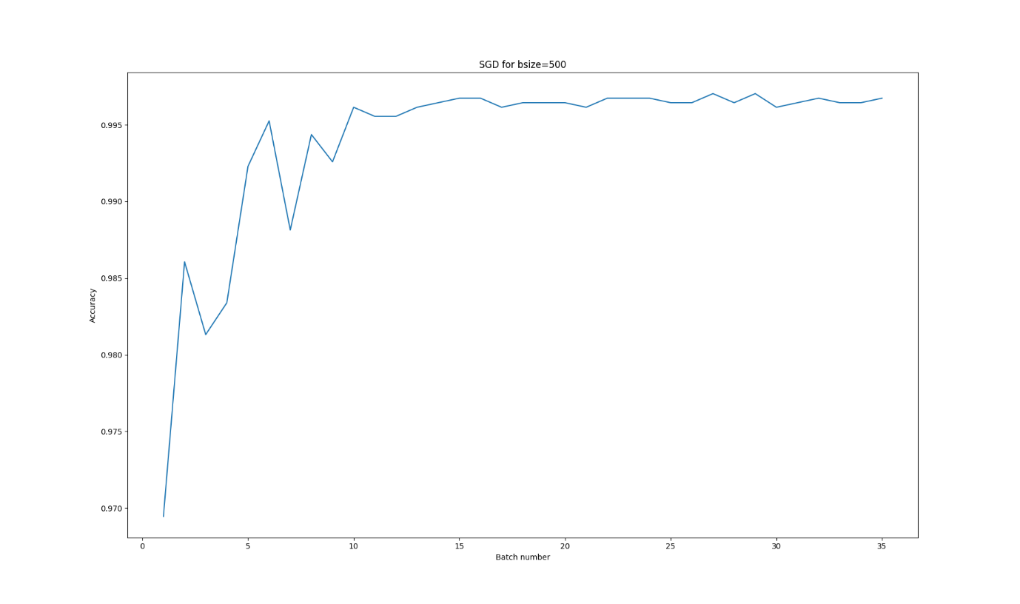

1. PAC

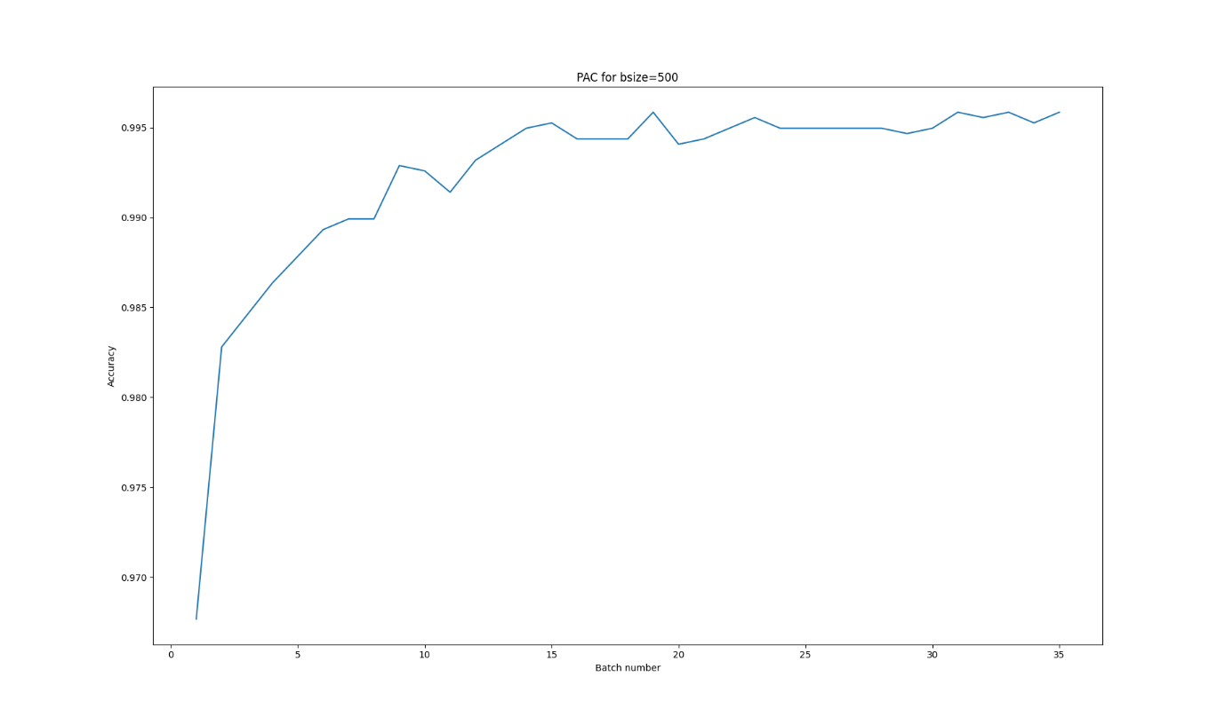

MULTIPLE LINE PLOTS FOR BETTER VIZUALISATION :

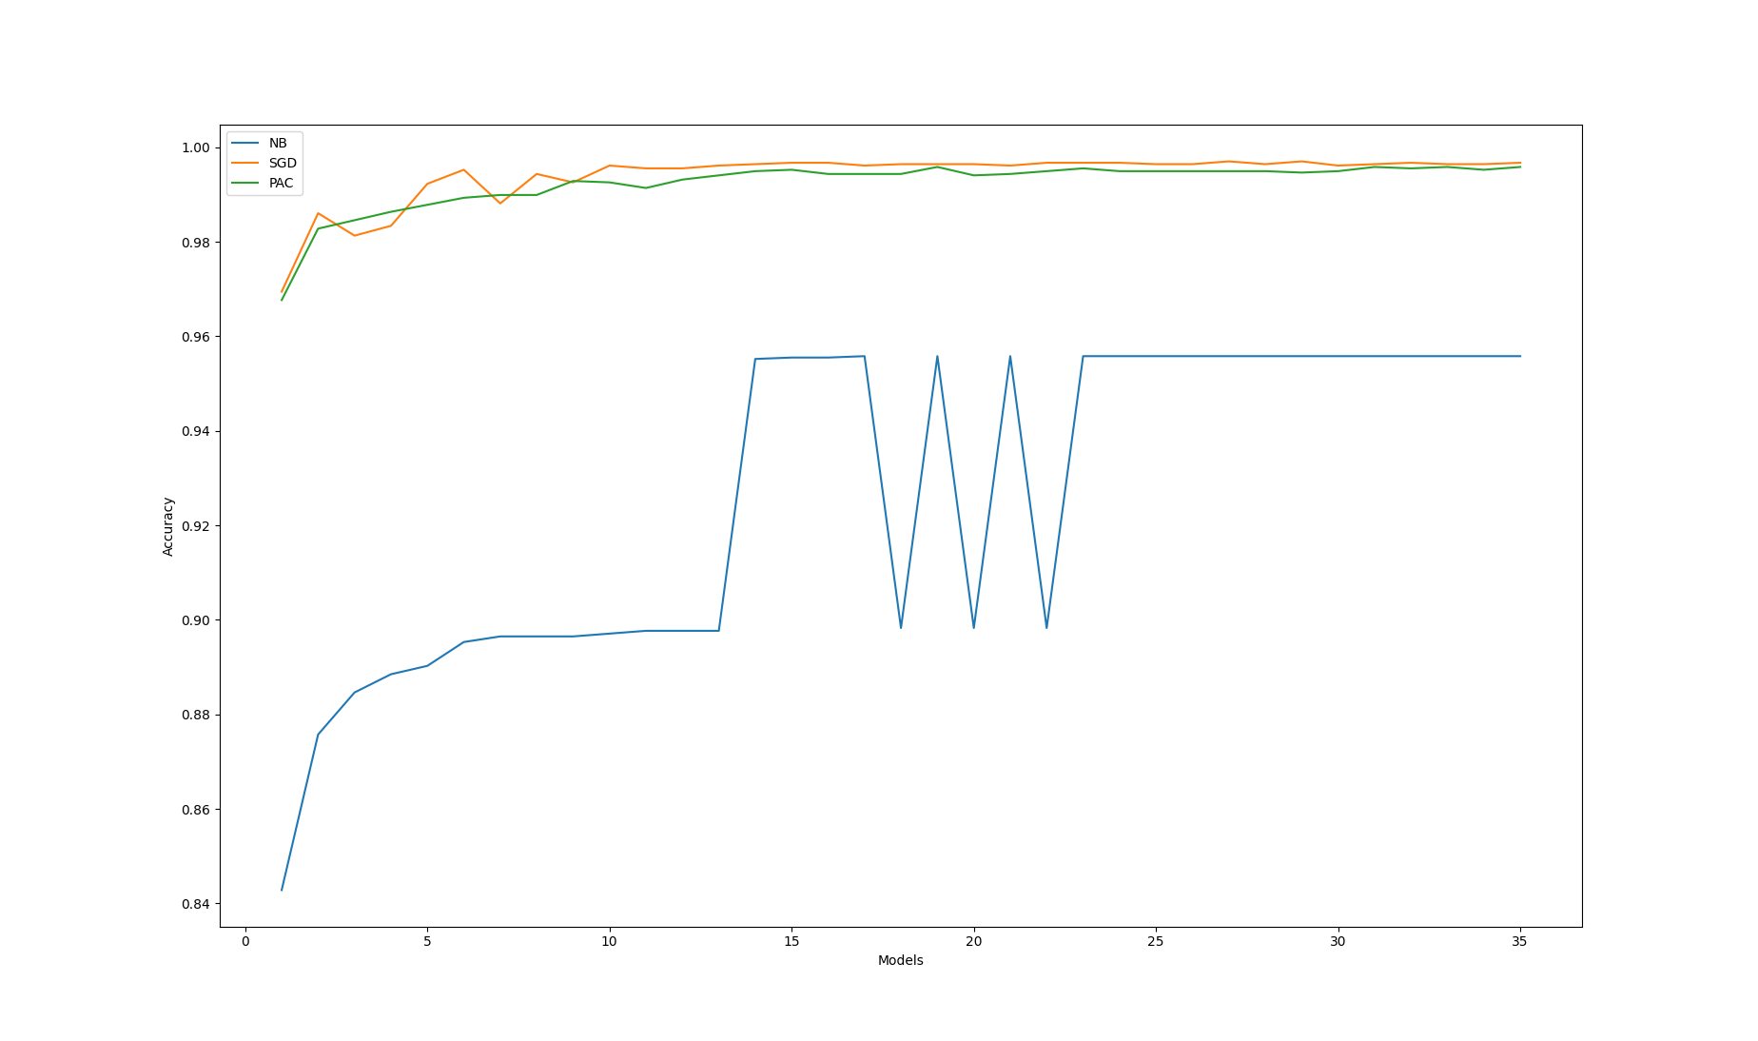

BAR PLOT FOR COMPARING ACCURACIES OF DIFFERENT MODELS:



1. Comparing Models for different batch sizes:
2. Naïve Bayes

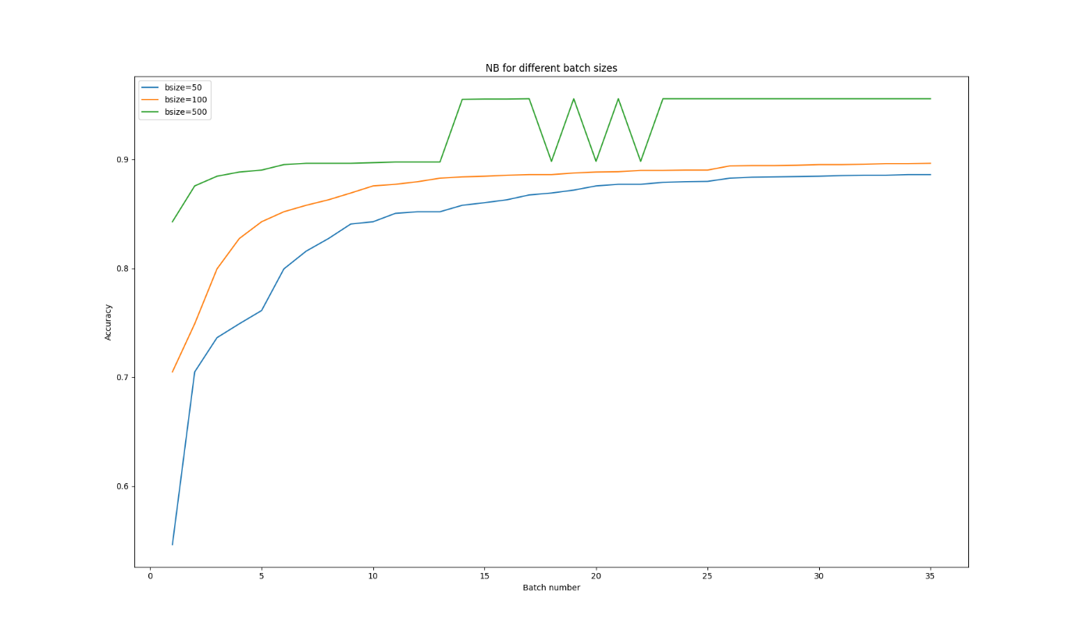

1. SGD

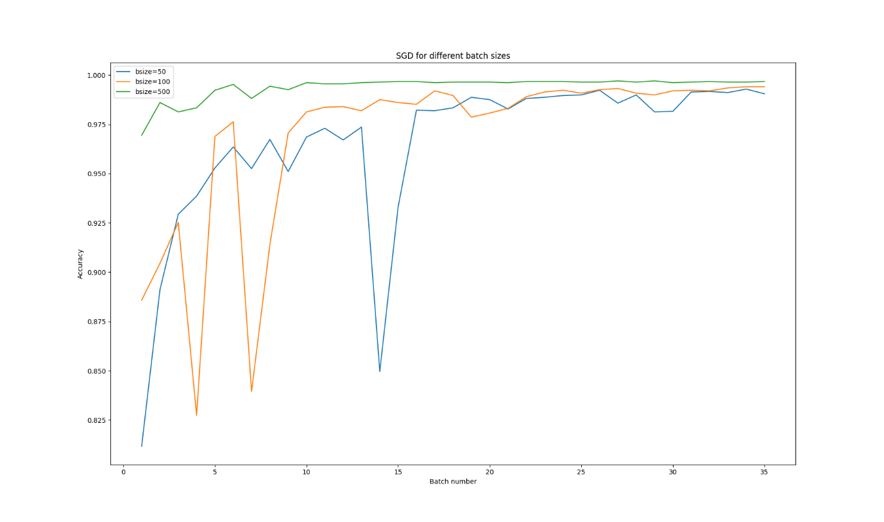

1. PAC

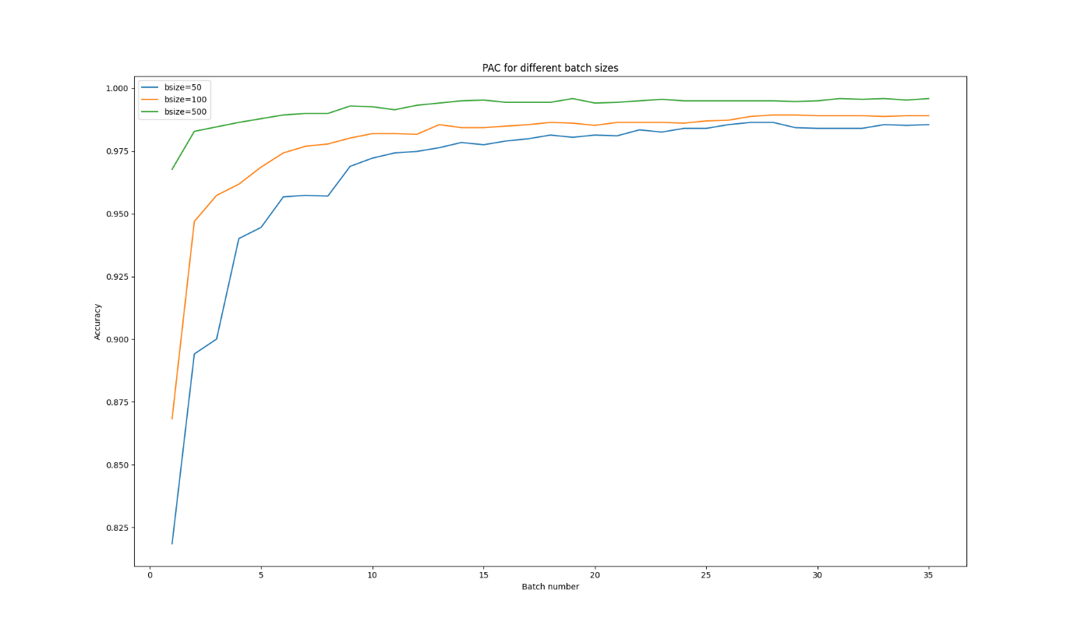

1. Hyper Parameter Tuning and Preprocessing :
2. Naïve Bayes:
3. Preprocessing - With Stopwords

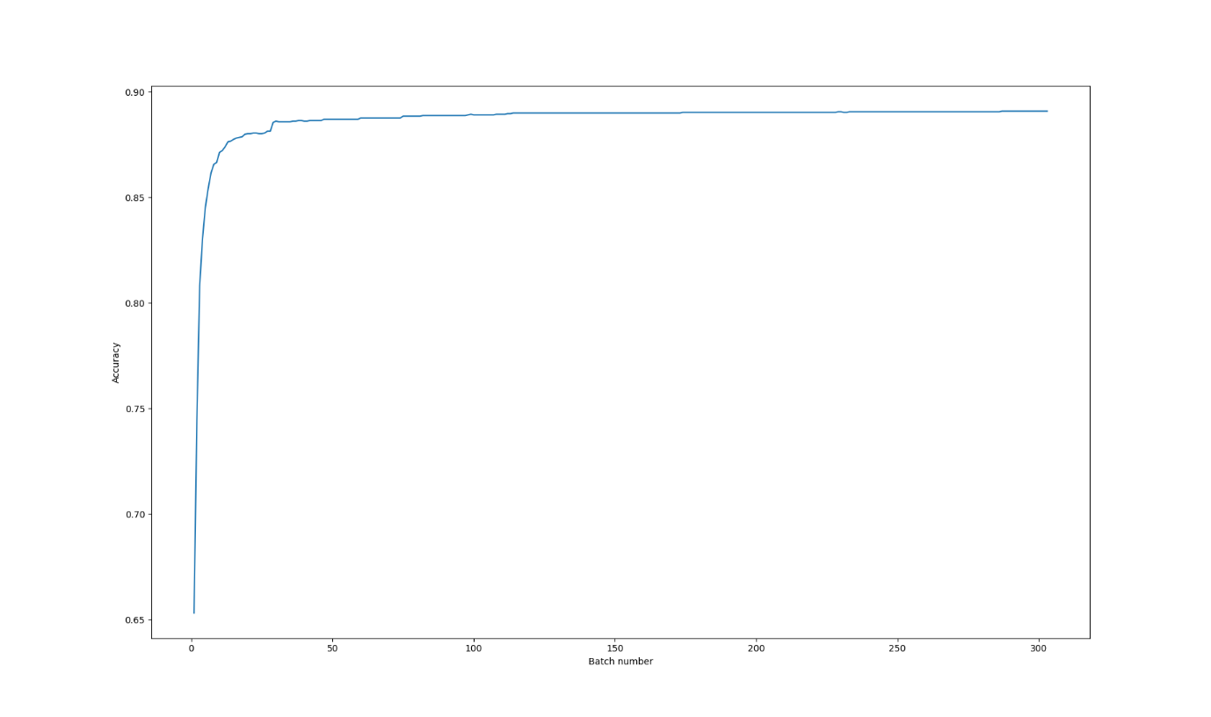

1. Hyper Parameter tuning

alpha = 2, fit prior false

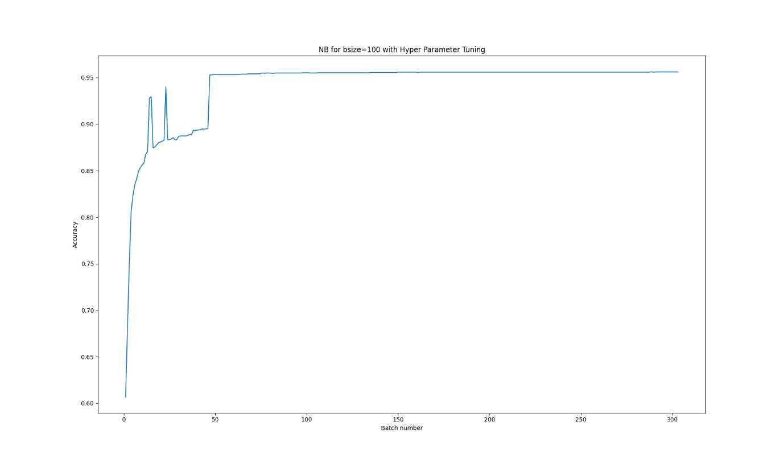

1. SGD – MLP
2. Hyper parameter tuning

Loss function – Perceptron loss

Eta0=1

Learning rate =constant

Bsize=100

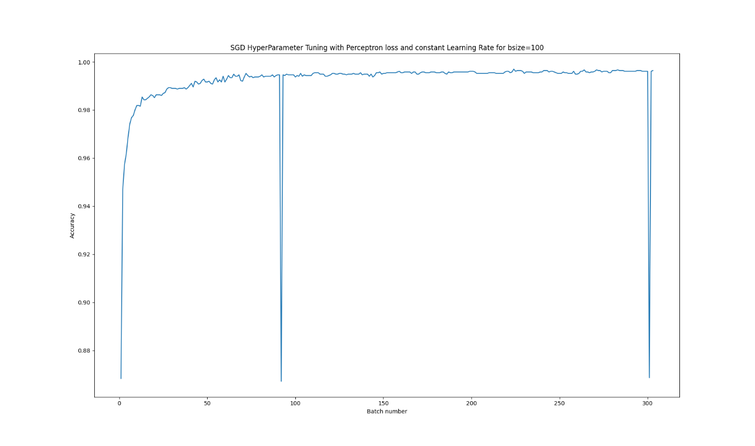

1. Preproccessing

Used stopwords

Added Hash vectorizer features=2**10

Removed Stemming

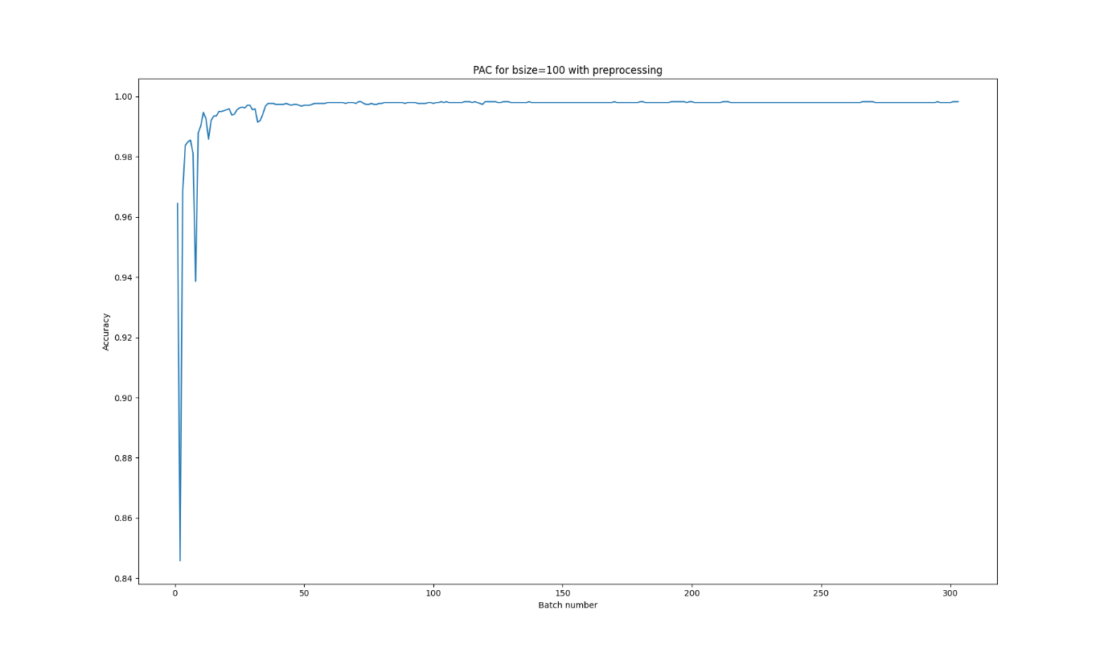

1. PAC

parameters : shuffle=True, warm_start=True

